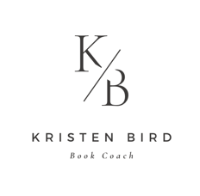
CLIENT INTAKE Q&A
- Name
- Email
- Which package are you interested in?
- Where are you in the book-writing process?
- What gives you the most satisfaction in your book-writing process and your writing life?
- What gives you the most frustration in your book-writing process and your writing life?
- What are your goals and objectives for your book? Why are you writing it?
- What is the point of your book? What are you trying to say about human nature and the world?
- What is your book about in 250 words or less? What happens in it?
- Why are you the best person to write this book? What do you bring to the work?
- What are you publishing goals? Traditional publishing? Self-publishing? An independent or hybrid model?
- Who is your target audience, based on your genre and topic?
- Do you belong to a writer’s group? What feedback have you gotten from them?
- Have you worked with an editor on this project in particular? What was the feedback you received from them? What was your experience working with them?
- What are you looking for in a book coach?
- Are you familiar with using Microsoft Word’s Track Changes tool?
- Is there anything else you’d like to share with us about your project or your writing journey?
- Upload a 10-page sample of your novel (if you have it). Please make sure that it is in standard manuscript formatting: double spaced, 12-point Times New Roman font with 1-inch margins on all sides.

